1. 
2. 
3. 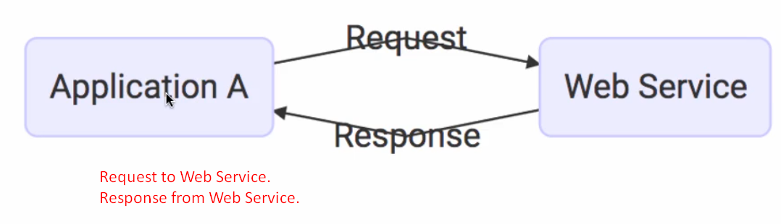
4. 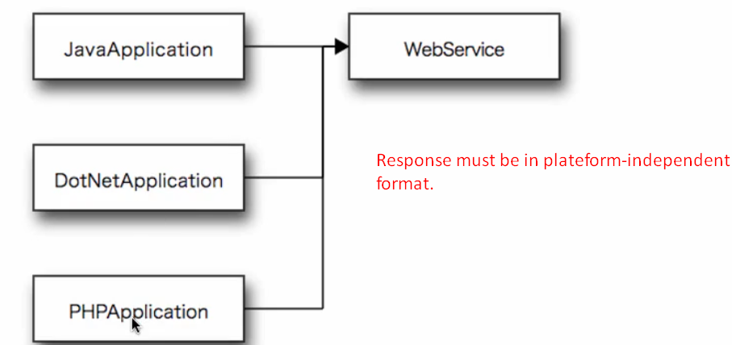
5. Two formats which are platform-independent.
   1. XML.
   2. JSON.
6. 
7. 